**Project # 3 Part 1: Object Recognition**  
*CSC 391: Computer Vision*  
Caroline Li  
April 3, 2019

My objective is for the algorithm to identify if an image is an area of agriculture or not. Below are sample images from the dataset I consider for training and testing. Each image is 200 x 200 pixels and contains primarily agriculture or non-agriculture. The images below illustrate the variety that exists within the two classes.

*Agriculture*

|  |  |  |  |  |
| --- | --- | --- | --- | --- |
|  |  |  |  |  |
|  |  |  |  |  |

*Non-Agriculture*

|  |  |  |  |  |
| --- | --- | --- | --- | --- |
|  |  |  |  |  |
|  |  |  |  |  |

In agriculture plots, vegetation appears uniform and grid-like. In non-agriculture plots, it’s more random. Based on this, I decided to explore a few commonly used features before determining texture analysis to be a possible way of extracting meaningful features for later classification.

I first explored the histogram of oriented gradients (HOG) feature descriptors. With the HOG feature descriptor, gradients of the image are used as features. Since vegetation contains edges and corners, and vegetation is grid-like in agriculture images, I believed that perhaps HOG feature descriptors would look more uniform in agriculture images and more random in non-agriculture images.

In the next pages are examples of HOG feature descriptors from images in the dataset. Upon visual inspection, there is not a consistent difference between HOG feature descriptors from agriculture and non-agriculture images, unless we compare an agriculture image with an image containing just river, which has an obvious difference, for example.

*Agriculture*

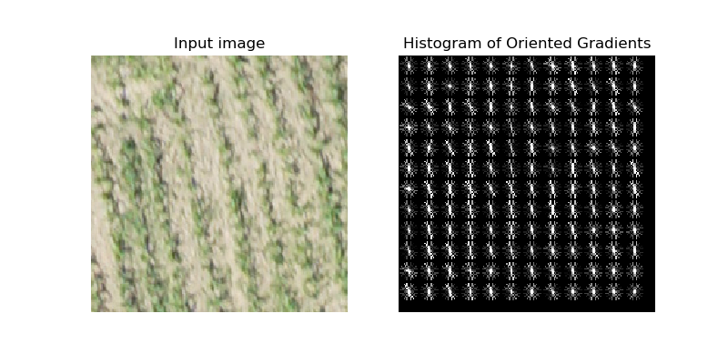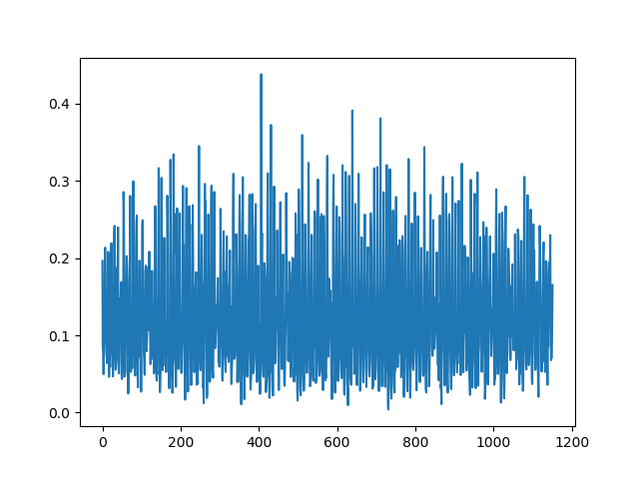

*Agriculture*

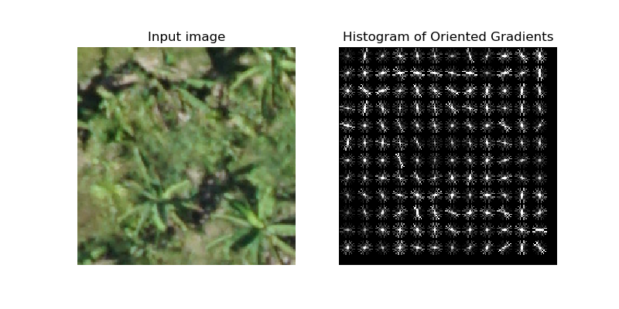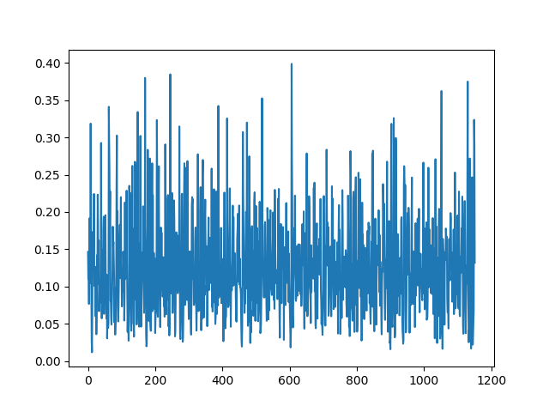

*Agriculture*

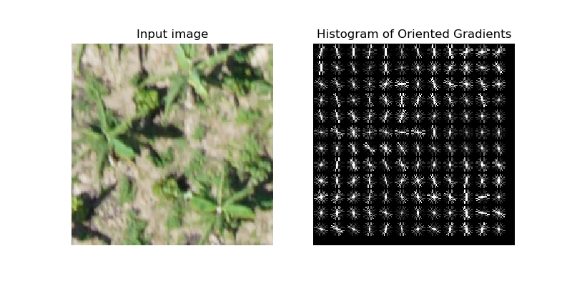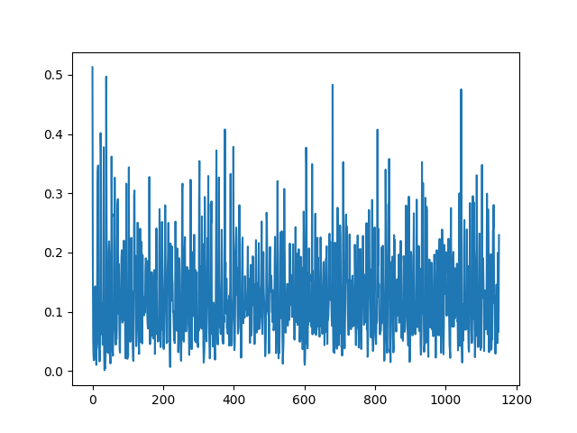

*Agriculture*

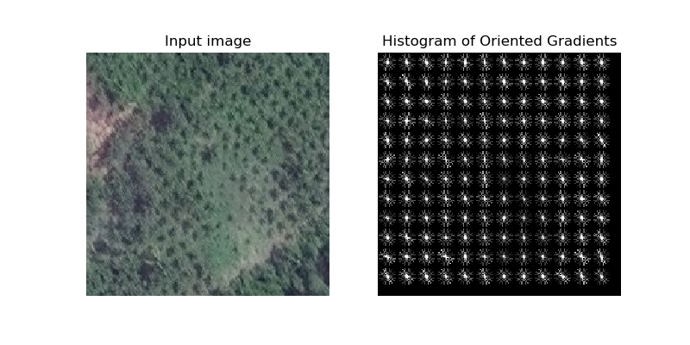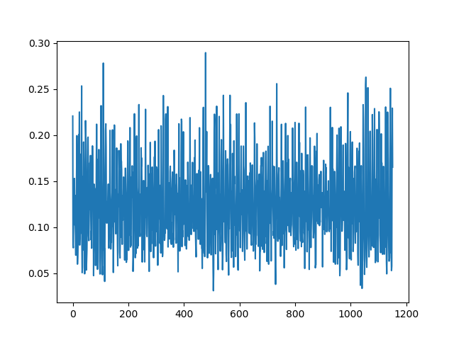

*Non-agriculture*

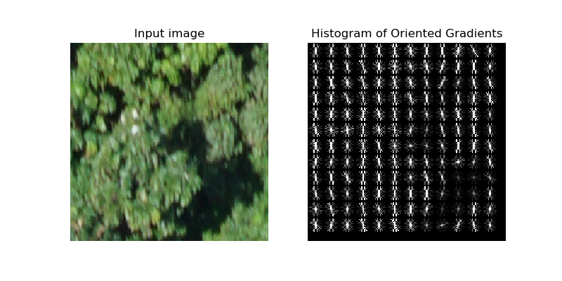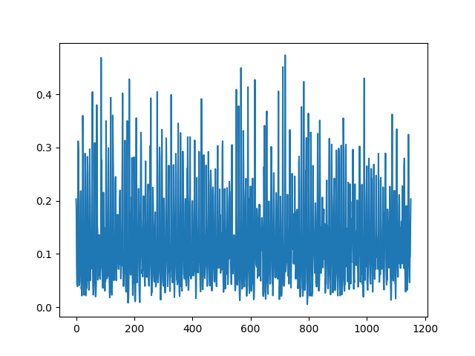

*Non-agriculture*

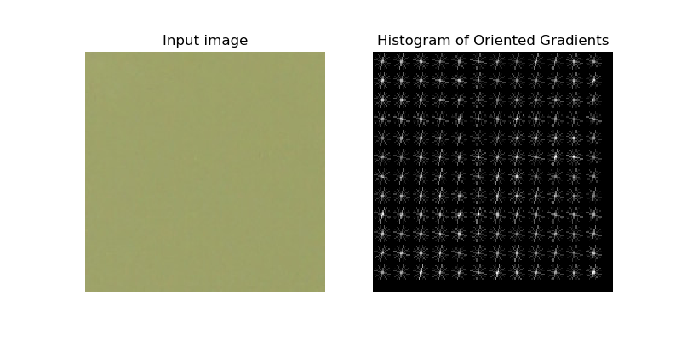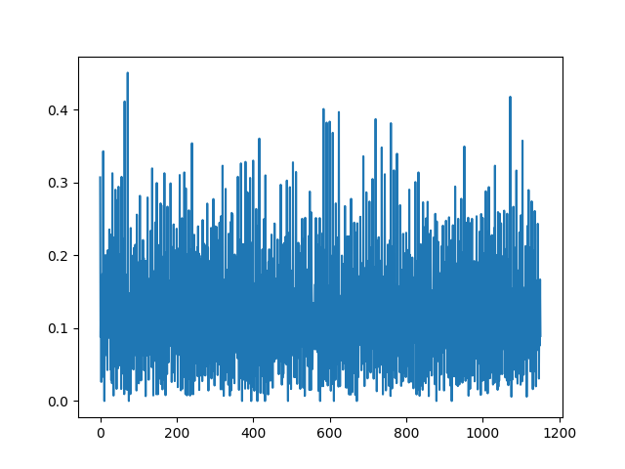

*Non-agrictulure*

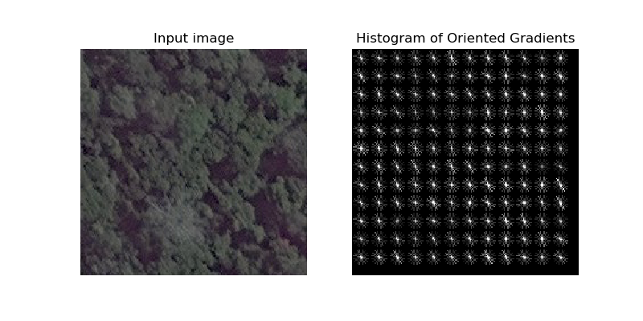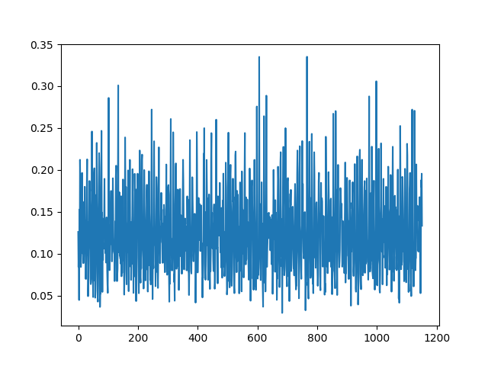

I next explored texture analysis with the Gabor filter. Below are example images from exploration. With the Gabor filter, we can start seeing differences between agriculture and non-agriculture images pretty well.

When comparing a patch of agriculture with an image of a river, the Gabor filter returns the two images as very similar. This may be because of noise in the river image which read as similar to the patch of agriculture as it’s fairly uniform. This may be a problem with classification between agriculture and non-agriculture areas that are more uniform. For the human eye, it’s clear the non-agriculture image is not an agriculture plot.

|  |  |
| --- | --- |
|  |  |

With a more obvious non-agriculture image, we can see that textures between the two images have a clearer difference.

|  |  |
| --- | --- |
|  |  |

Below is an example of an agriculture image that’s pretty hard to discern even for a human. We can see that the results from the Gabor filter are pretty similar as well.

|  |  |
| --- | --- |
|  |  |

Below is a comparison with two satellite images. There is some similarity, but we can see that grid-like texture in the agriculture image at frequency of 0.40.

|  |  |
| --- | --- |
|  |  |